**SUPERVISED LEARNING**

Supervised learning is a field of machine learning that maps an input to an output based upon the given input output pairs. It refers a function from labelled training dataset consisting of a set of data. A supervised learning algorithm checks the training data and produces a function which can be used for mapping new variables.

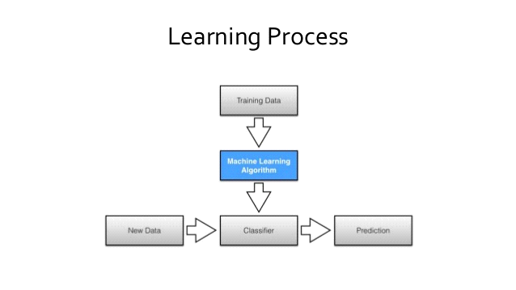

**UNSUPERVISED LEARNING**

Unsupervised learning is a sub-division of machine learning that trains itself based upon the given input un-labelled format from its test data that means only the input variable (X) is given without any prediction of the output variable(Y). This can be further classified and trained based on the previous experience and gets stored as algorithm.

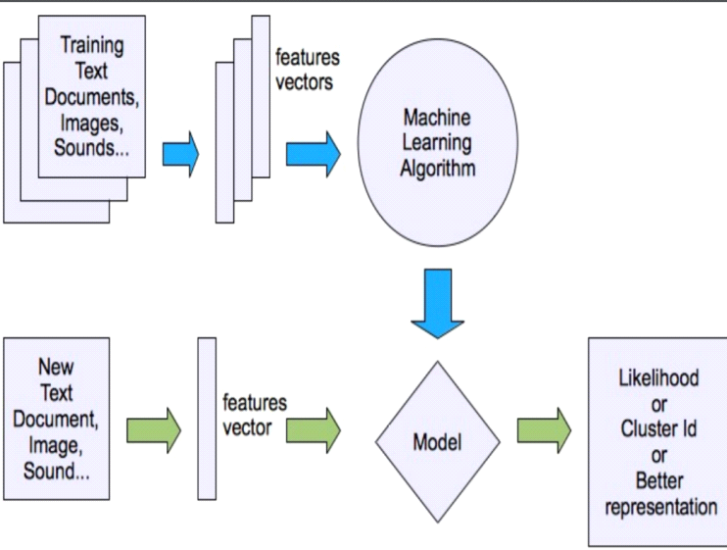

**REINFOURCEMENT LEARNING**

Reinforcement learning (RL) is a field of Artificial Intelligence concerned with how software agents owe to take actions to maximize cumulative reward. In machine learning the environment is formulated as Markov Decision Process (MDP), as many reinforcement learning algorithms utilize dynamic programming technique.

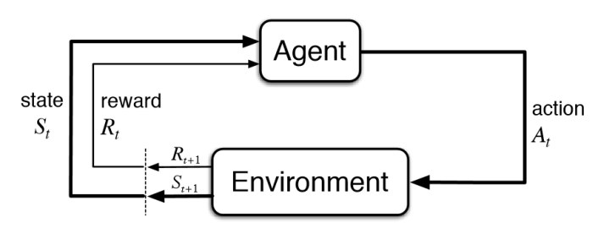

**DATA CLASSIFICATION IN DIABETES PREDICTION**

This project aims to achieve an accuracy of the dataset reading that we are

Classified, here we are going to obtain dataset of various factors for the

Prediction of diabetes. This data set contains patient’s information like Glucose

Level, Number of pregnancies, Blood pressure, Skin thickness, Insulin

Level, BMI, Age, Diabetes pedigree function, Age. We are going to find whether a person has diabetes or not with the help of data classification process with these previously collected parameters.

**DATA CLASSIFICATION IN WINE PRODUCTION**

This project aim is to find the type of wine with the help of given datasets. we are going to get the datasets of various factors for finding type of wine .this dataset contains information like volatile acidity, citric acid, residual sugar, sulphate, quality. We can able to find the type of wine with the help of data classification process with the parameters collected.